**NEHA SAWANT – PA0B**

**OUPUT RESULTS**

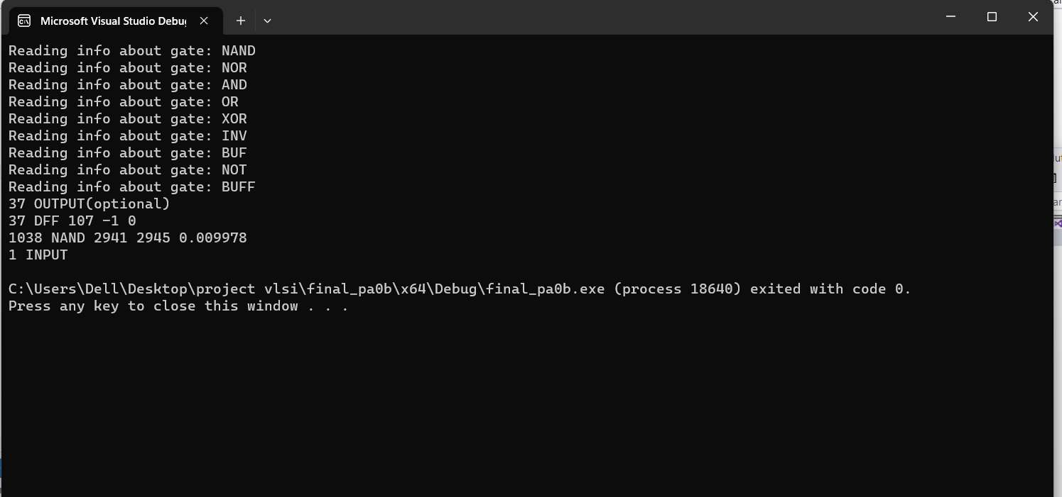

**Inputs set to:**

